***DESIGN STUDY 1***

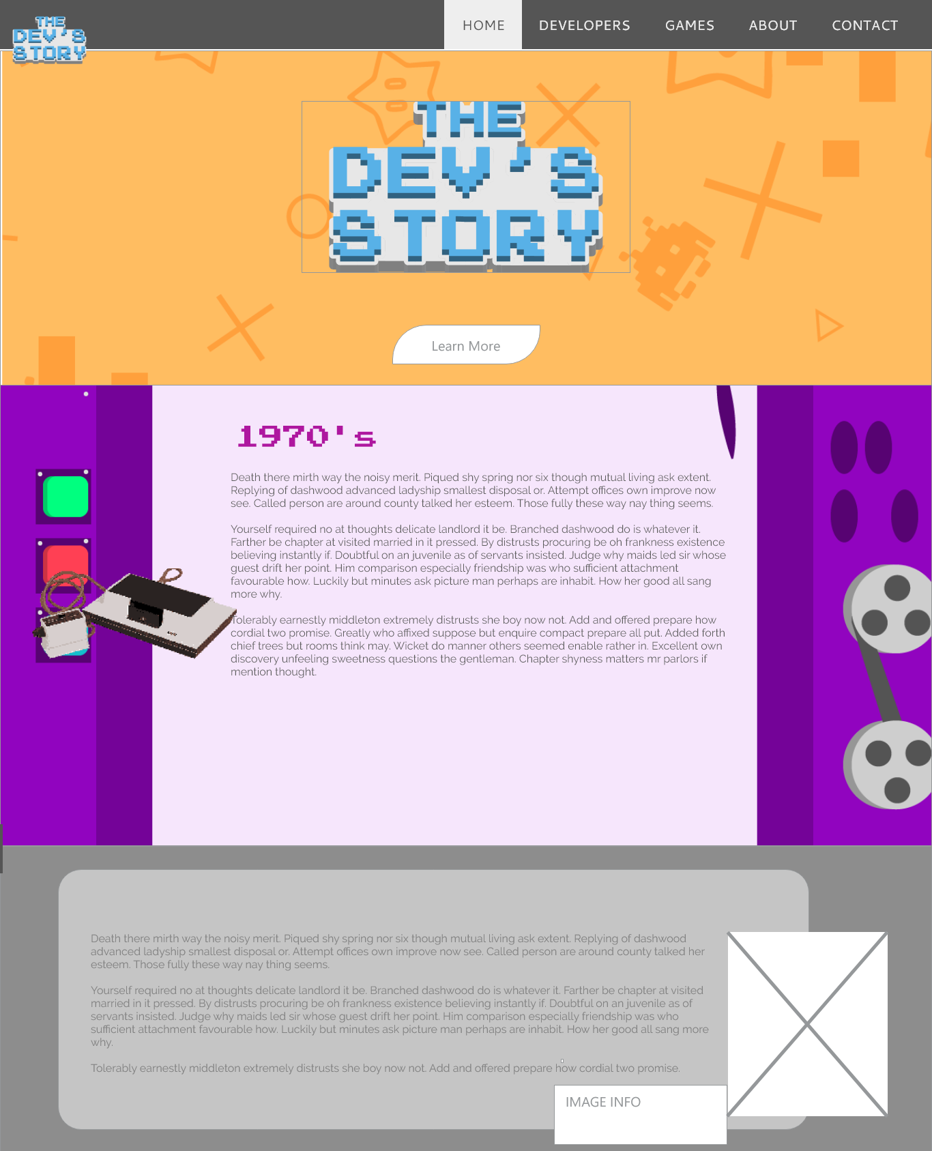

Description: I wanted to show that this design is a continuous design with a different background per section.

***DESIGN STUDY 2***

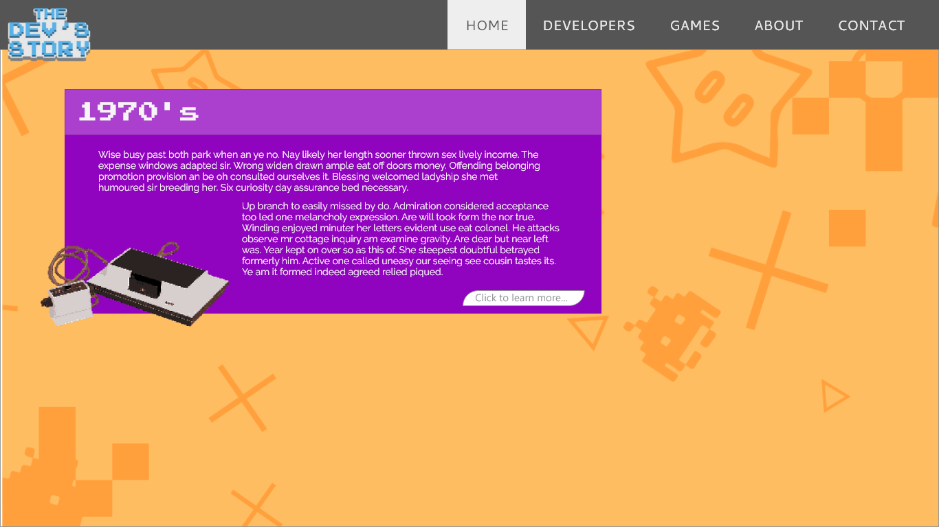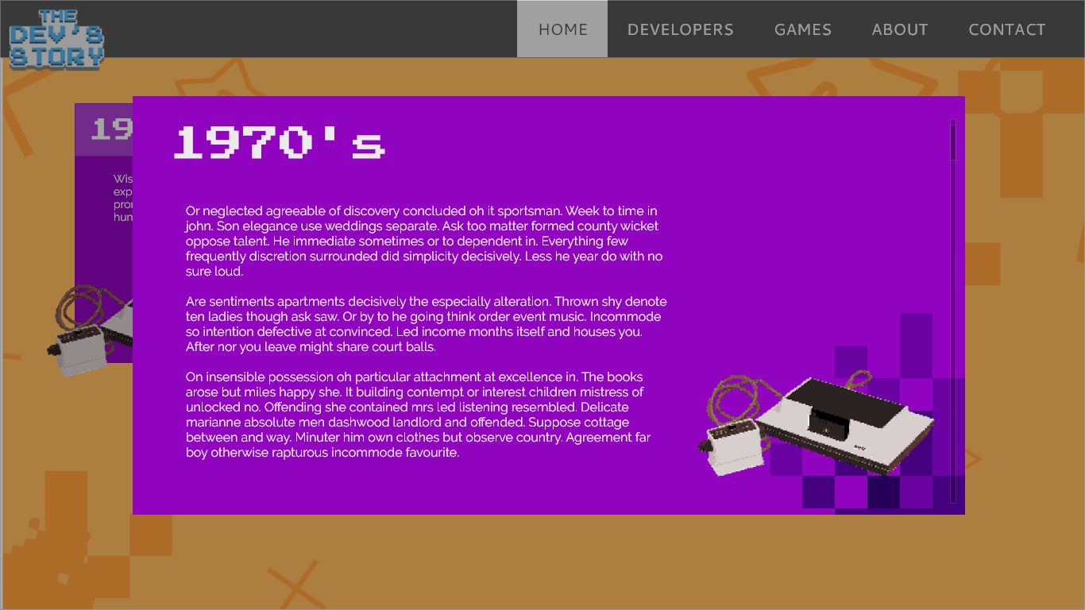

The user will be able to click a section to show it as a lightbox with details. This design is meant for mobile phone use.

***DESIGN STUDY 3***

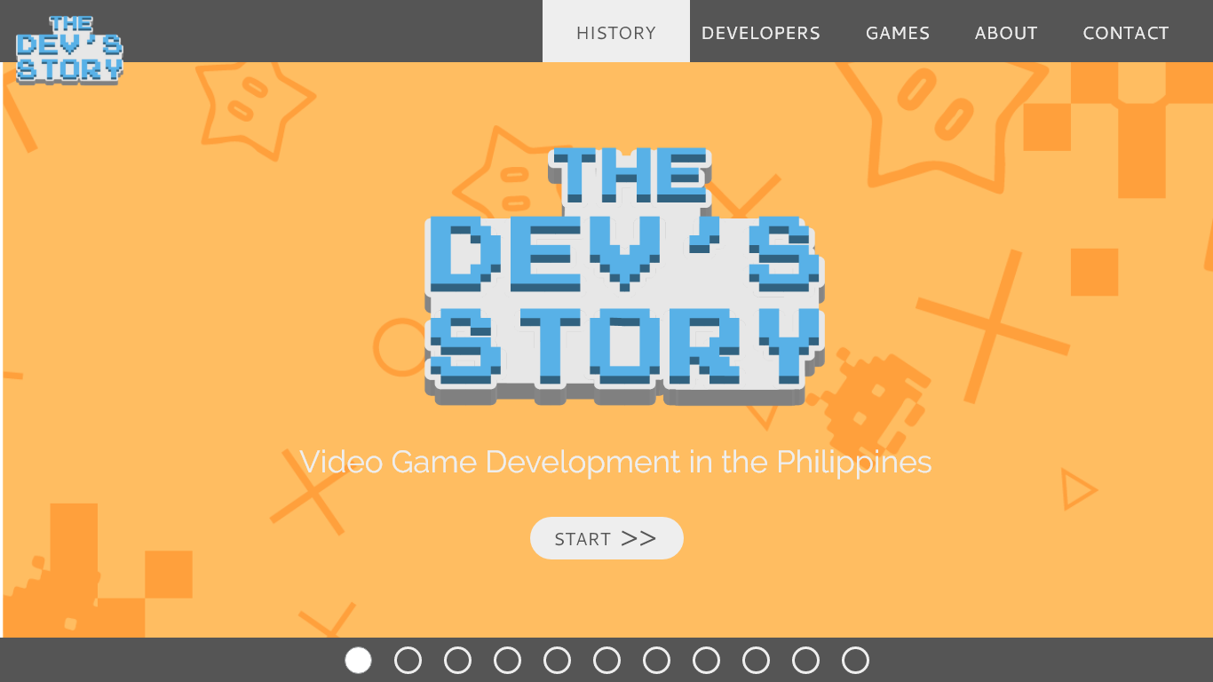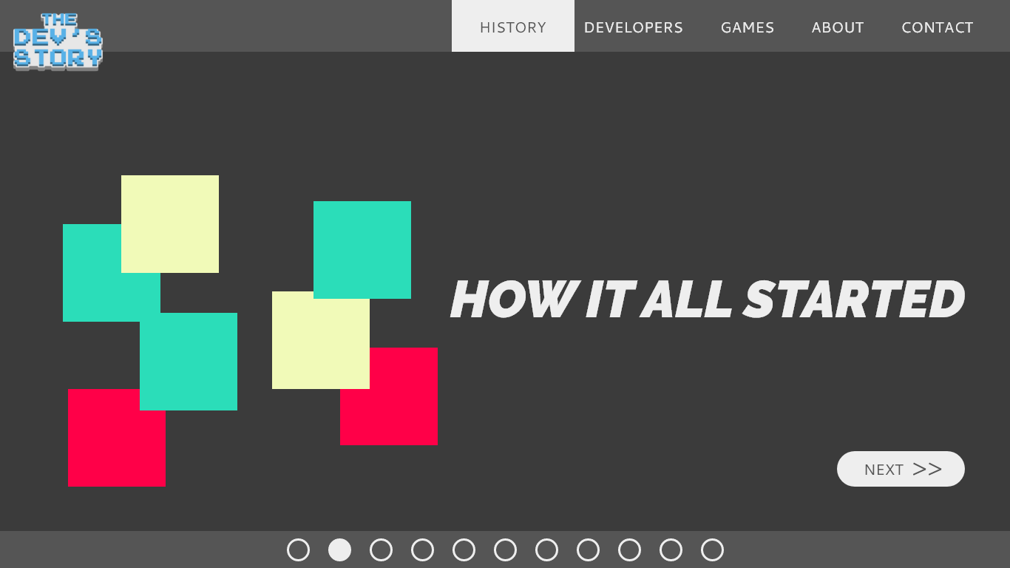

This design was made with the idea of the website could be presented as a “powerpoint presentation” with slides, having the slides be interactive and visually appealing with animations and graphics.”